Name : Sk.Kashifa

Registration no:192121135

Online course registration system

Class diagram :

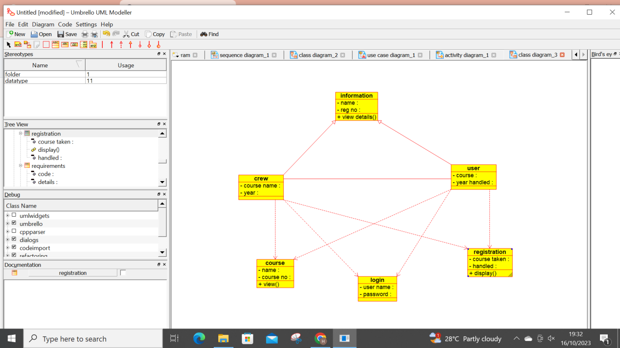

Activity diagram :

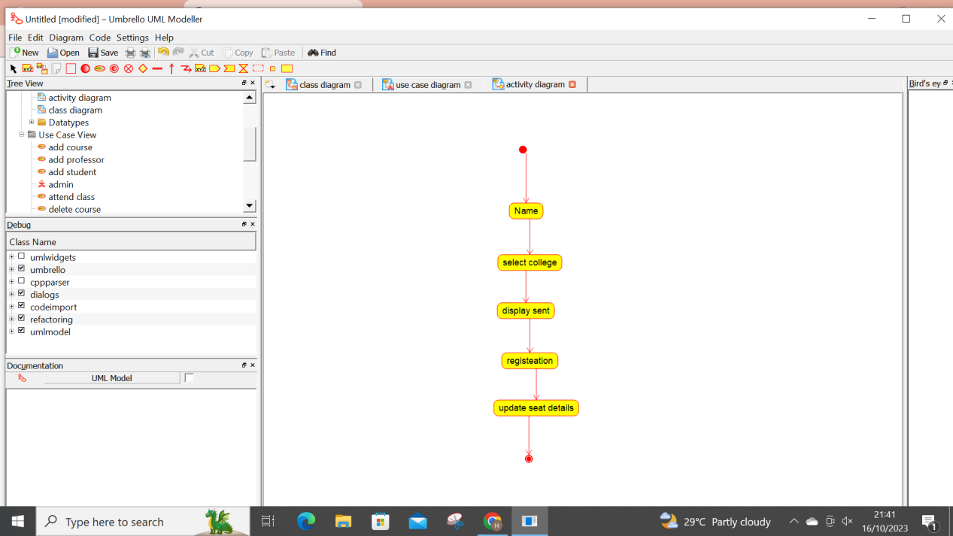

Use case Diagram :

